**Scripting Elements:**

**index.jsp:**

<%@ page language="java" contentType="text/html; charset=ISO-8859-1"

pageEncoding="ISO-8859-1"%>

<!DOCTYPE html>

<html>

<head>

<meta charset="ISO-8859-1">

<title>JSP Scripting Elements</title>

</head>

<body>

<%!

int a=20;

String name="Welcome";

int square() {

return a*a;

}

%>

<h2>

<%=name+" Everyone!!"%><br>

</h2>

<%

int b=10;

out.println("b: "+b);

if(b<100) {

out.println("<br>b is smaller than 100");

}

else {

out.println("<br>b is greater than 100");

}

%><br><br>

<%

out.println("Numbers from 1-20: ");

for(int i=1;i<=20;i++) {

out.println(i+", ");

}

%><br><br>

<%="a: "+a%><br>

<%="a's square: "+square()%>

</body>

</html>

**Output:**

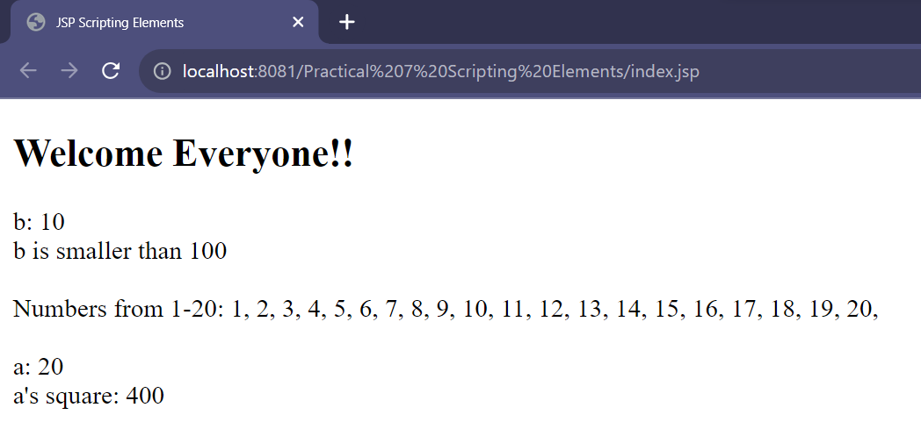

**Directives:**

**date.jsp:**

<%@ page language="java" contentType="text/html; charset=ISO-8859-1"

pageEncoding="ISO-8859-1"%>

<!DOCTYPE html>

<html>

<head>

<meta charset="ISO-8859-1">

<title>Date</title>

</head>

<body>

<%@ page import="java.util.Date" %>

<%

Date date = new Date();

%>

<p>The current date and time is: <%= date %></p>

</body>

</html>

**Output:**

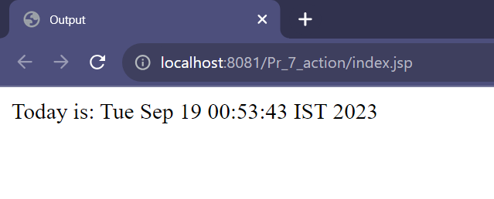

**info.jsp:**

<%@ page language="java" contentType="text/html; charset=ISO-8859-1"

pageEncoding="ISO-8859-1"%>

<!DOCTYPE html>

<html>

<head>

<meta charset="ISO-8859-1">

<title>Info</title>

</head>

<body>

<%=getServletInfo()%>

</body>

</html>

**Output:**

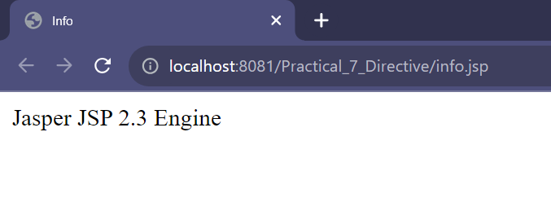

**Implicit Objects:**

**index.jsp:**

<%@ page language="java" contentType="text/html; charset=ISO-8859-1"

pageEncoding="ISO-8859-1"%>

<!DOCTYPE html>

<html>

<head>

<meta charset="ISO-8859-1">

<title>Index</title>

</head>

<body>

<%

String name= "Welcome!";

out.println("<h2>"+name+"</h2>");

%>

<%

session.setAttribute("session_name","JSP program works!");

%>

<form action="output.jsp" method="get">

Enter your name: <input type="text" name="name" Placeholder="Name.."/>

<input type="submit" value="Submit"/>

</form>

</body>

</html>

**output.jsp:**

<%@ page language="java" contentType="text/html; charset=ISO-8859-1"

pageEncoding="ISO-8859-1"%>

<!DOCTYPE html>

<html>

<head>

<meta charset="ISO-8859-1">

<title>Output</title>

</head>

<body>

<%

String myname = request.getParameter("name");

out.println(myname+"'s");

%>

<%

String sname = (String)session.getAttribute("session_name");

out.println(sname);

%>

</body>

</html>

**Output:**

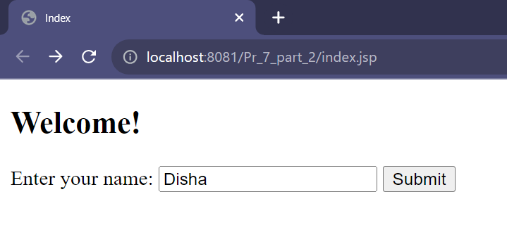

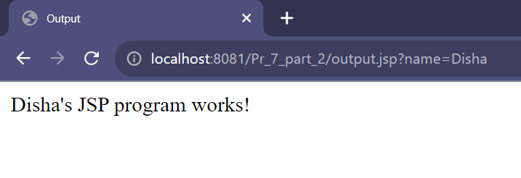

**index.jsp:**

<%@ page language="java" contentType="text/html; charset=ISO-8859-1"

pageEncoding="ISO-8859-1"%>

<!DOCTYPE html>

<html>

<head>

<meta charset="ISO-8859-1">

<title>Index</title>

</head>

<body>

<form action="welcome.jsp">

Enter name:

<input type="text" name="uname">

<input type="submit" value="go"><br/>

</form>

</body>

</html>

**welcome.jsp:**

<%@ page language="java" contentType="text/html; charset=ISO-8859-1"

pageEncoding="ISO-8859-1"%>

<!DOCTYPE html>

<html>

<head>

<meta charset="ISO-8859-1">

<title>Welcome</title>

</head>

<body>

<%

String name=request.getParameter("uname");

out.print("Welcome "+name);

%>

</body>

</html>

**Output:**

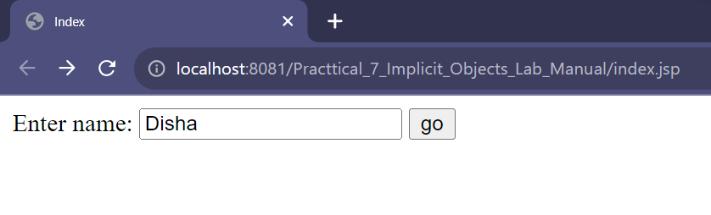

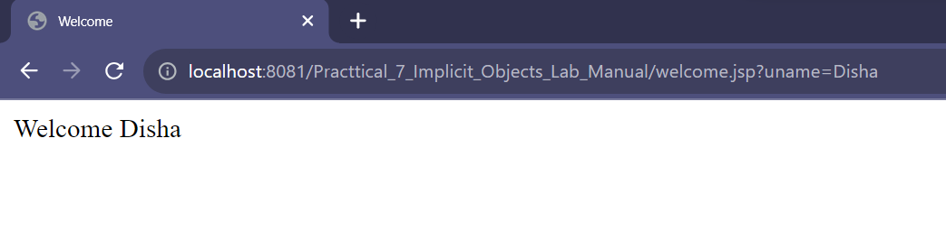

**Action Tags:**

**index.jsp:**

<%@ page language="java" contentType="text/html; charset=ISO-8859-1"

pageEncoding="ISO-8859-1"%>

<!DOCTYPE html>

<html>

<head>

<meta charset="ISO-8859-1">

<title>Index</title>

</head>

<body>

<jsp:forward page="output.jsp" >

<jsp:param name="name" value="<br>Welcome to my page<3"/>

</jsp:forward>

</body>

</html>

**output.jsp:**

<%@ page language="java" contentType="text/html; charset=ISO-8859-1"

pageEncoding="ISO-8859-1"%>

<!DOCTYPE html>

<html>

<head>

<meta charset="ISO-8859-1">

<title>Output</title>

</head>

<body>

<% out.print("Today is: "+java.util.Calendar.getInstance().getTime()); %>

<% =request.getParameter("name") %>

</body>

</html>

**Output:**

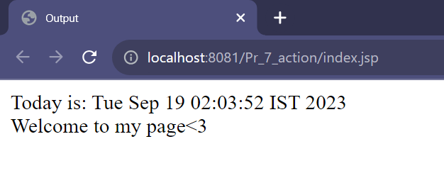

**Expression Language:**

**index.jsp:**

<%@ page language="java" contentType="text/html; charset=ISO-8859-1"

pageEncoding="ISO-8859-1"%>

<!DOCTYPE html>

<html>

<head>

<meta charset="ISO-8859-1">

<title>Index</title>

</head>

<body>

<form action="output.jsp" method="get">

Enter name: <input type="text" name="name" Placeholder="Name.."/>

<input type="submit" value="Submit"/>

</form>

</body>

</html>

**output.jsp:**

<%@ page language="java" contentType="text/html; charset=ISO-8859-1"

pageEncoding="ISO-8859-1"%>

<!DOCTYPE html>

<html>

<head>

<meta charset="ISO-8859-1">

<title>Output</title>

</head>

<body>

<h1>Hello, ${param.name}!</h1>

</body>

</html>

**Output:**

